Student Safety Contract

Red Oak Middle School Science

General Guidelines

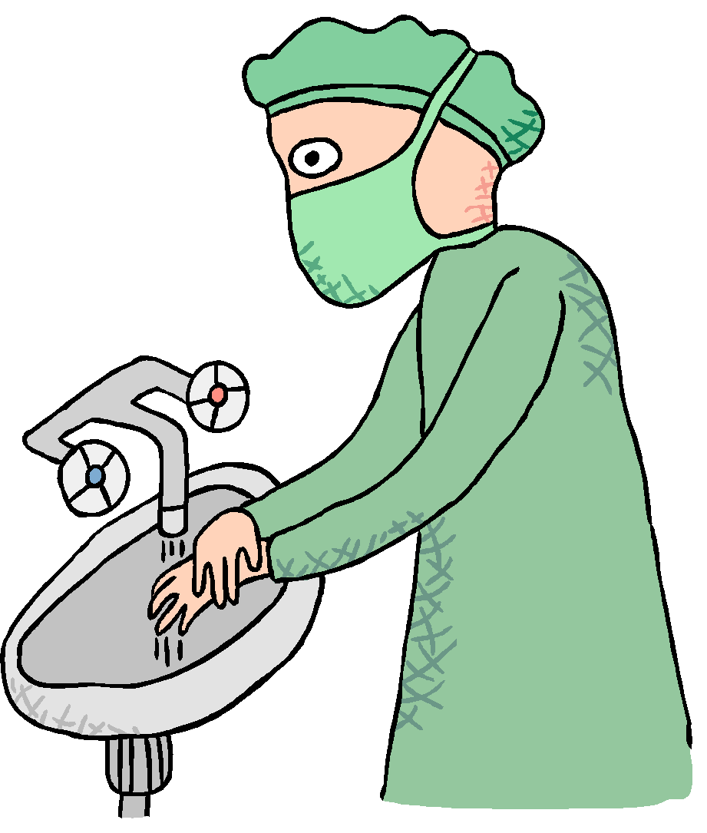
Do NOT touch any equipment, chemicals, or any other materials until instructed to do so.

Read ALL procedures carefully before starting a lab activity.

Horseplay, practical jokes, and pranks are dangerous and prohibited.

Never eat, drink, chew gum, or taste anything in the science room.

Wash hands with soap and water after experiments.

Clean all work areas and equipment at the end of each lab. Return all equipment clean and in working order to the proper storage area..

Experiments must be monitored at all times. Never wander around the room during a lab, stay at your lab station. You are responsible for the success of your lab.

Handle all living organisms in a humane manner. Preserved biological matter is to be treated with respect and disposed of properly.

If the instructions are unclear as to how to handle equipment, it is the responsibility of the student to ASK for assistance.

Never open storage cabinets or enter the prep/storage room without permission from the teacher.

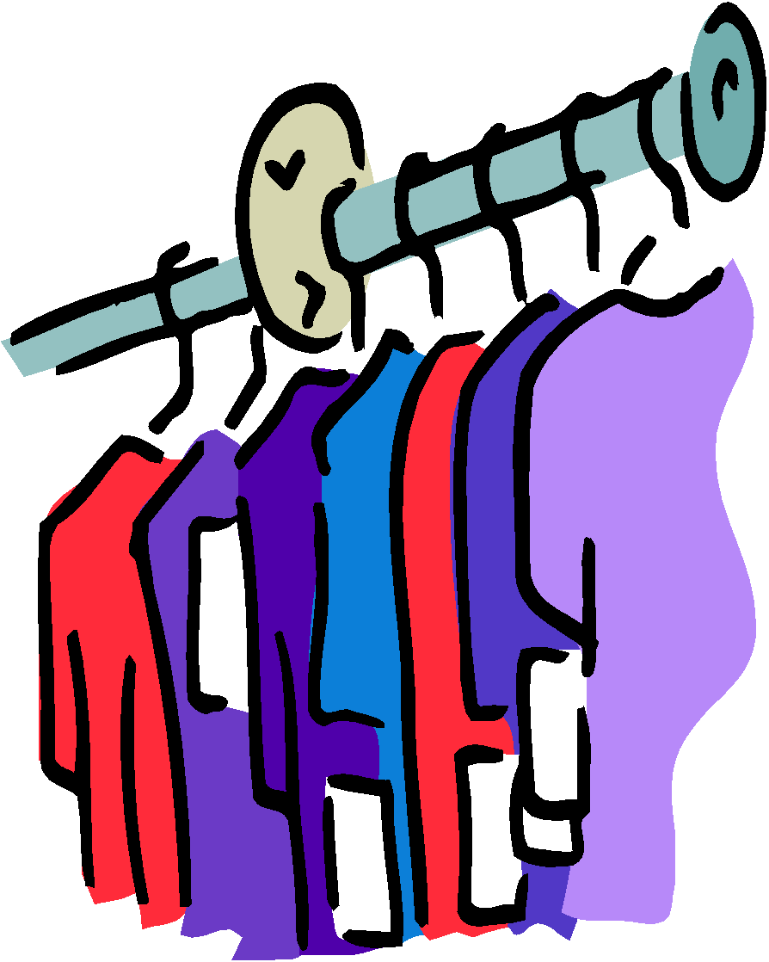
Clothing

Anytime chemicals, heat, or glass are used, students will wear goggles. No exceptions!

Long hair, dangling jewelry, and loose or baggy clothes are a hazard during lab.

Lab aprons should be worn during labs and long hair should be tied back.

Chemicals

All chemicals in a lab are to be considered dangerous. Do not smell, touch, or taste any chemicals.

Wear safety glasses or goggles when instructed. Never remove safety glasses or goggles during an experiment. There will be no exception to this rule.

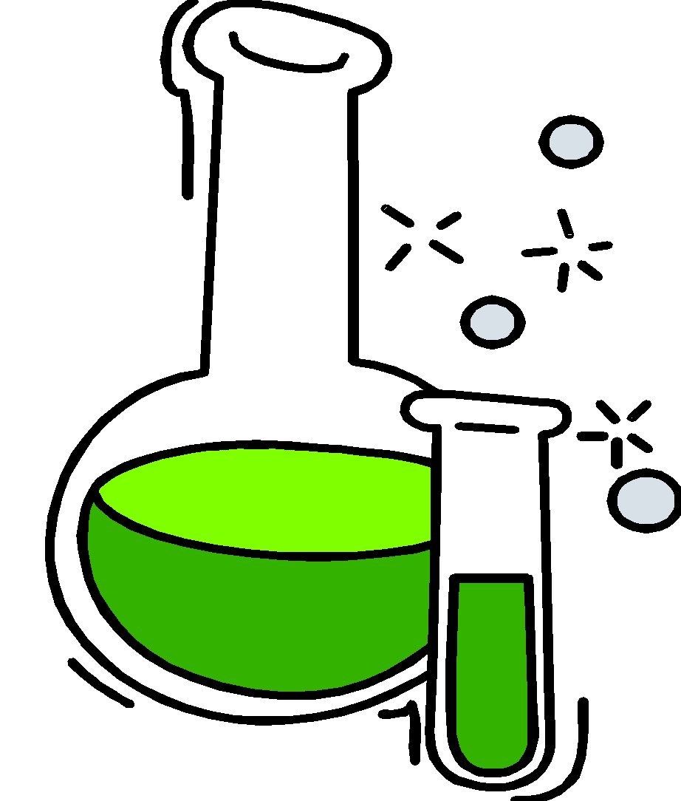
Never return unused chemicals to their original containers.

Dispose of all chemical waste properly.

Solid chemicals, metals, matches, filter paper, etc. are disposed of in designated trash cans, not in the sink. Ask the teacher where lab waste should go.

Keep hands away from face, eyes, mouth, and body while using chemicals.

Accidents

Report any accident (fire, spill, breakage, etc.), injury (cut, burn, etc.), or hazardous condition (broken equipment, etc.) to the teacher immediately.

If chemicals should splash in your eyes, immediately flush eyes with running water from the eyewash station & notify the instructor.

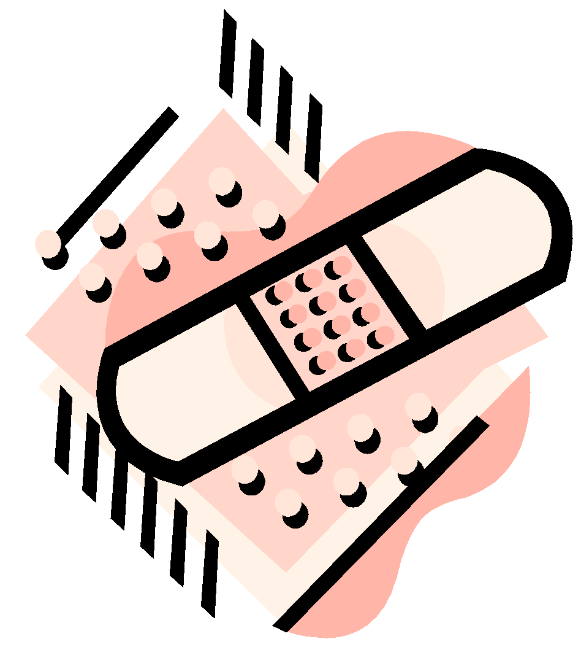
Broken glassware should never be cleaned up by students. Notify the teacher.

Never use chipped or broken glassware.

When removing an electrical plug from a socket, grasp the plug and pull. Do not grab the cord and yank it out of the socket.

Fire & Heat

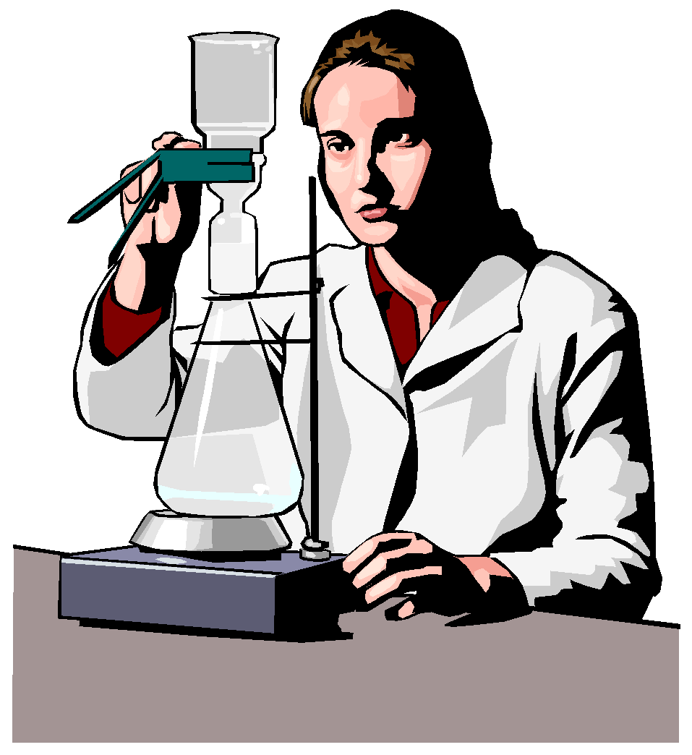
Exercise extreme caution when using a gas burner. Make sure long hair is tied back.

Do not put any substance into the flame unless instructed to do so. Light burners only when instructed to.

Never reach over an open, exposed flame & never look into a container that is being heated.

Never leave a lit burner unattended!

Student Safety Contract
Red Oak Middle School Science

Agreement

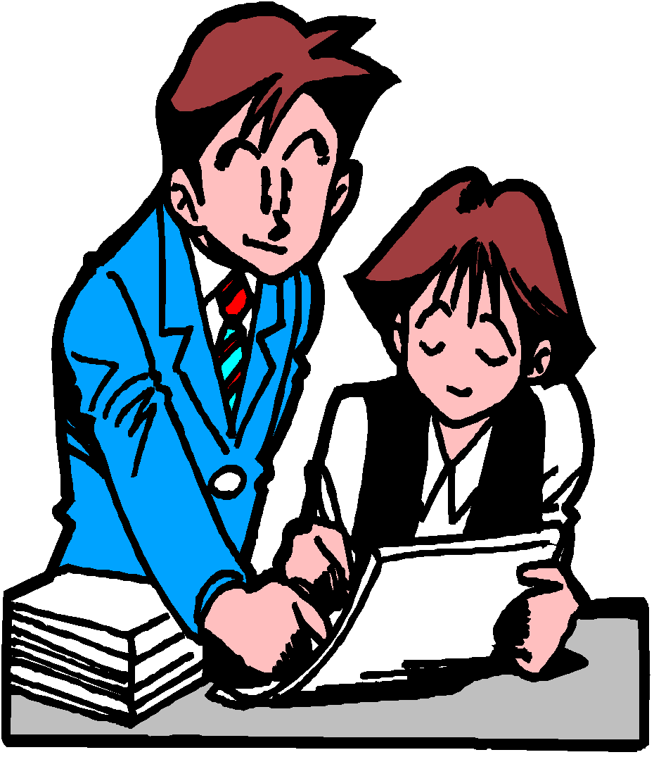
Student will abide by all safety regulations and guidelines within this contract.

Any violation of this contract that produces unsafe conduct may result in the loss of lab privileges, detention, and/or a lowered lab grade.

By signing this contract, the student and parents (or guardians), each agree with the contract and accept responsibility for the information presented within.

No student will be allowed to perform labs without this safety contract signed.

This contract will be kept on file with the student in their science notebook, and the signature page will be turned into their teacher

Student Signature:

X ________________________________________ Date: __________

Parent/Guardian Signature:

X ________________________________________ Date: __________

Questions or Concerns: _____________________________________________

__________________________________________________________

Questions/Allergies – Please Answer ALL Questions…

Do you have any allergies? ……………. Circle one: Yes or No

If so, list allergies… _____________________________

Do you wear Contact Lenses?………… Circle one: Yes or No

Are you color blind? ……………………. Circle one: Yes or No

Do you have asthma? …………………… Circle one: Yes or No

Is there any other medical condition that the science teacher should

be aware of? Circle one: Yes or No

If so, list conditions… _____________________________

