Name ______________________________________ Date ______________ Period _____

**Frog Dissection Lab Practical Review**

1. In the box next to the structure, name the system that it is part of:

|  |  |
| --- | --- |
| **Structure** | **System** |
| Heart | Circulatory |
| Internal Nares | Respiratory |
| Tongue | Digestive |
| Stomach | Digestive |
| Gall Bladder | Digestive |
| Maxillary Teeth | Digestive |
| Lung | Respiratory |
| Kidney | Excretory |

1. Where does the large intestine lead to? *Cloaca*
2. How many lungs does a frog have? *2*
3. Where does the small intestine lead to? *Large intestine*
4. How many lobes does a frog’s liver have? *3*
5. The stomach leads to what organ? *Small intestine*
6. How many kidneys does a frog have? *2*
7. How many chambers does a frog’s heart have? 3
8. What is another name for the tympanum? *eardrum*
9. In the box next to the structure, describe the function of the organ listed:

|  |  |
| --- | --- |
| **Structure** | **Function** |
| Large intestine | *Collects wastes and absorbs water* |
| Gall Bladder | *Stores bile* |
| Liver | *Removes wastes from blood and produces bile* |
| Stomach | *Digests food* |
| Small Intestine | *Absorbs digested food/chemical digestion* |
| Heart | *Pumps and collects blood* |
| Lung | *Removes oxygen from the air* |
| Tympanum | *Vibrates to hear* |
| Kidney | *Removes wastes from blood to create urine* |

1. ****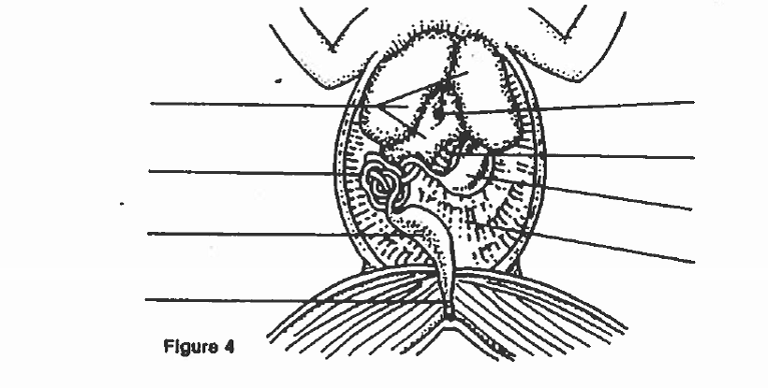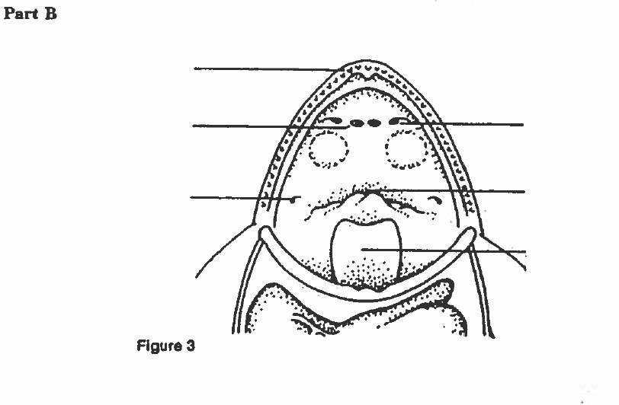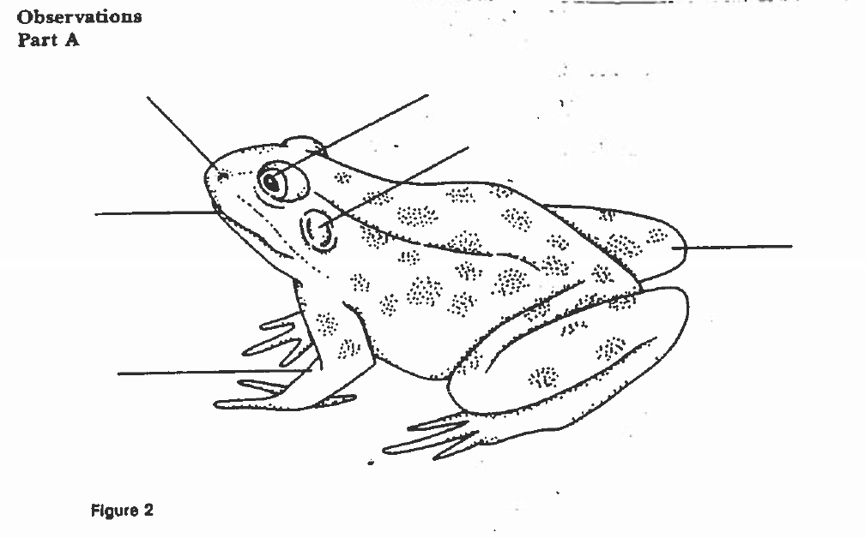Label the diagrams below:

D Mouth

W Gall Bladder

X Large Intestine

V Small Intestine

G Maxillary Teeth

I Vomerine Teeth

H Internal Nares

K Eustachian Tubes

E Hind leg

C Tympanum

A External Nares

L Tongue

Z Cloaca

Y Stomach

U Liver

T Ureter

S Urinary Bladder

R Kidney

P Lung

O Heart

Q Ventricle

N Left Atrium

M Right Atrium

J Gullet/Esophagus

F Fore Leg

B Eyes