Name ______________________________________________________ Date _____________ Period ______

Adaptations Test Review

- Describe the different methods that plants use to disperse their seeds. Wind, water, and animals move seeds away from the parent plant.
- Why would plants need to disperse their seeds away from the parent plant? Seeds must germinate away from the parent plant in order to have access to enough light and moisture = so it does not compete with the parent plant for resources.
- Plants that reproduce asexually, through vegetative propagation, have an advantage to those who reproduce sexually using pollen. Why? The plantlets do not have to rely on animals or wind for pollination or seed dispersal.
- Explain why male cardinals (red birds) are brightly colored. Males are brightly colored to attract mates.
- A willow ptarmigan is a bird that lives in the tundra biome. Why does its plumage turn from brown in the summer to white in the winter? Its plumage color helps it blend in with its surroundings.
- Certain lizards have brightly colored detachable tails. Why is this particular adaptation beneficial? Predators are more likely to grab the brightly colored tail that would then come off and allow the lizard to escape.
- A monarch butterfly is brightly colored. What kind of adaptation is this? Structural Why is the bright coloration an advantage to this organism’s survival? Its bright coloration serves as a warning to predators that it does not taste good or that it is poisonous.

- If the black rocks were replaced with bright green seaweed, what would happen to the population of fish in the picture below? _The bright green fish would be able to hide and their population would increase and the dark colored fish would be easier to see and get picked off by the predators more.
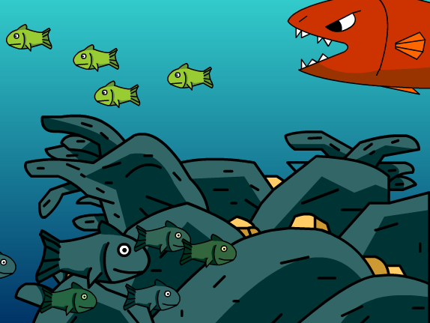
Dark colored fish

Bright green fish

- What is the picture below showing? Natural selection
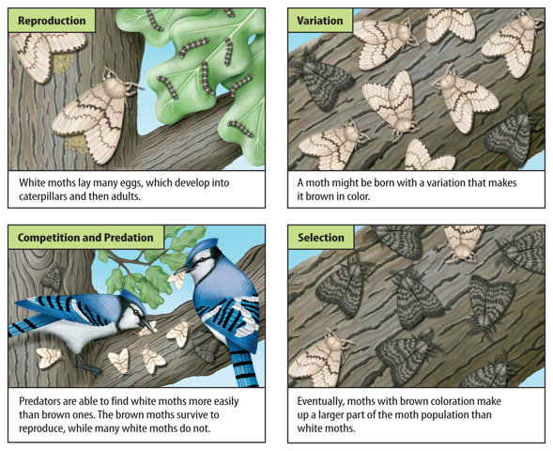

- Fireflies flash their lights to attract a mate. Fireflies that cannot produce light are less likely to find a mate and reproduce. For this reason, there are few fireflies that cannot produce light. This is an example of Natural selection.
- Describe what happens in plant dormancy. The plant stops growing during the winter.
- Explain what Charles Darwin is responsible for. Charles Darwin is responsible for creating the theory of Natural Selection and Evolution.
- Give an example of a structural adaptation. Feathers/beak/webbed feet/camouflage/mimicry
- Give an example of a learned behavior language/hunting/driving a car
- Define physiological adaptation. An adaptation that includes internal or cellular features that help an organism survive their environment.
- Give an example of a physiological adaptation. Snake venom/octopus ink/bioluminescence
- Explain migration. A behavioral adaptation in which the animal moves locations at different times of the year.
- Explain hibernation. A behavioral adaptation in which the animal reduces its metabolism to conserve energy during the winter.
- Define instinct. Inherited behaviors or behaviors that an organism is born knowing.
- Give an example of an instinct. Bird building a nest/sea turtle moving toward the ocean/spider spinning a web
- Different forms or version of a species’ is known as variations
- Define Natural Selection. Any trait that is more advantageous for a certain environment that allows the organism with that trait to be more successful than other individuals in the population …survival of the fittest!
- Define adaptation. A characteristic that helps a living organism survive in its environment.

