Name ______________________________________________________ Date _____________________ Period ____________

Unit 5 CBA Review

- Another name for a pharynx is the epiglottis. When a person swallows food or drink, the pharynx closes over the trachea. What is the function of the pharynx? It closes to cover the trachea so food/drink does not enter the breathing passages.
- Nurse shark teeth are very important to their survival. Often sharks prey struggle in their mouths and teeth get loose or come out as a result. In sharks’ mouths, there are rows of teeth behind each tooth in its mouth. What is the function of having these extra teeth? When it loses a tooth it will have another to take its place.
- Using the Dichotomous Key below, identify this adult insect:
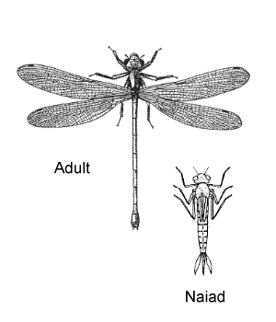
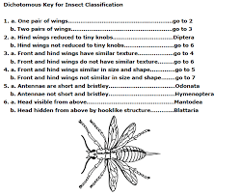
Odonata

- In the Chihuahuan desert of southwest Texas there are 2 types of pear cactus, ones with thorns and ones without thorns. Javelina and mule deer that inhabit the area eat the thorn less cactus routinely leaving the cactus with thorns alone. The thorns on the cactus are an example of a(n) adaptation
- How do fish gills help them survive? It allows the fish to obtain the dissolved oxygen in the water
- Butterflies mouthparts are straw-like whereas grasshopper mouthparts consist of sharp mandibles. What accounts for the differences in their mouthparts? Differences in feeding methods.
- Using the Dichotomous Key below, identify this plant.
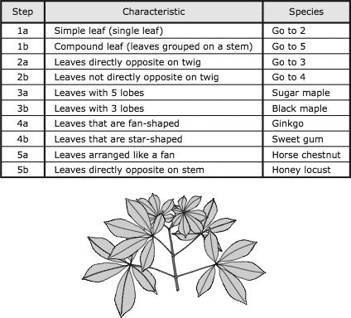
Horse Chestnut
- Explain why whales have to come up for oxygen and fish do not. Whales cannot take the dissolved oxygen from the water and must come up for air.
- Bones, organs, and muscles are all (internal/external) features. (circle one)
- Selectively breeding cows have led to different breeds. Which breed pictured below would be able to survive in colder environments and why? Highland cow because they have longer fur/thicker coat.
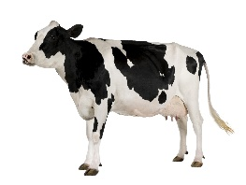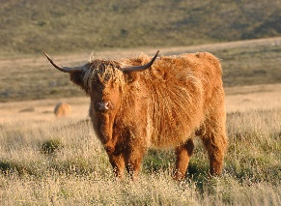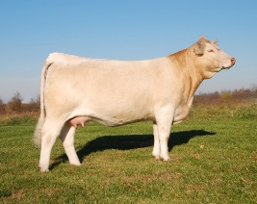
Holstein Cow Highland Cow Charolais Cow
- Bird bones are hollow so some scientists believe this helps them fly. Why would they think that? Scientists think it makes the birds lighter.
- What structure in plants transport water? Xylem
- What 3 ways do plants attract pollinators? Scent, texture, pattern, and color.
- Why do flowers with bulbs, like tulips, able to survive drought better than flowers without a bulb? They are able to store needed water in the bulb.
- Octopus are able to change their color, pattern and texture of their skin to better blend in with their environment. This is known as camourlage.
- What feature did Darwin see that were different in finches on the Galapagos Islands? Beaks
What was the differences due to? Different diet
What process did he say accounted for the differences? Natural selection
- Define selective breeding Humans breed two individuals that have desired characteristics hoping the offspring will inherit those characteristics.
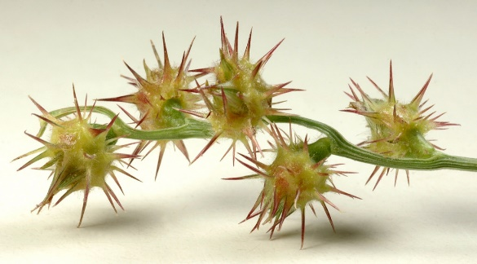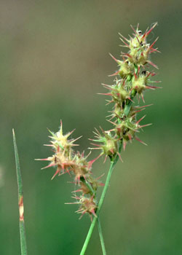
- What type of seed dispersal does the plant pictured above use? Animal dispersal
- Use the dichotomous key below to identify this organism:

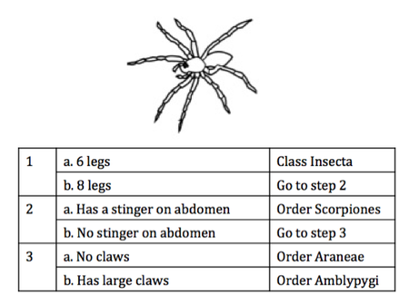
Order Araneae

