Name ___________________________________________________ Date ___________________ Period _________

Unit 9: Earth and Space Test Review

- What is the #1 characteristic that makes it possible for life to exist on a planet? Liquid water
- What is another characteristic needed for life to exist on a planet? Atmosphere with oxygen
- What 2 instances would keep a planet from having liquid water?
  - Too close to the star = too hot = water vapor
  - Too far away from the star = too cold = solid water (ice)
- What is the insulation feature of a spacesuit for? Temperature regulation
- How do astronauts get into space? _rocket_
- What does a space station provide for astronauts in space? Protection from cosmic radiation, air pressure, oxygen, water, food …
- Categorize the following into the T-Chart below: (the list will not be even)
Air pressure Atmosphere Carbon dioxide Cosmic radiation Gravity Light Microgravity Oxygen Water
Space Lacks | Present in Space
Air pressure | Light
Oxygen | Microgravity
Atmosphere | Cosmic radiation
Water
Carbon dioxide
Gravity

- What happens to astronauts’ bodies in space? Loss of muscle mass, reduced bone density, reduced circulation of blood Why does this happen? Microgravity
- What is the purpose of the Magnetosphere? Protect Earth’s atmosphere from cosmic rays and solar radiation_
- A planet that is the correct distance from a star so that the water cycle is possible would be considered within what area? Habitable Zone / Goldilocks Zone / Inhabitable Zone
- Why is Earth able to support life? Earth’s proximity to the Sun allows it to have liquid water
- Which planet(s) in the diagram would be able to support life similar to that on Earth?
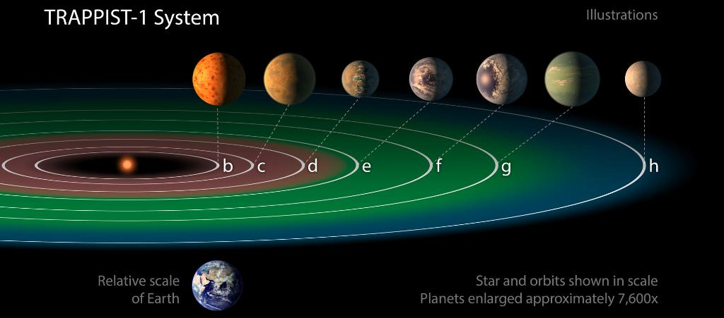
Planet e, f, & g
- What does the atmosphere provide for Earth? Shields the Earth from small collisions, protects Earth from Sun’s radiation, it allows gas exchange between plants and animals.
- Why is Mars not capable of supporting life? Mars is too cold
- When scientists look for a possible place to look for life, what are they looking for? Liquid water
- Why is it difficult for astronauts to exercise in space? Lack of gravity
- How do we know which way is up or down here on Earth? Gravity
- What do space suits provide for astronauts in space? _Oxygen, air pressure, protection from the Sun’s radiation, temperature regulation, waste management, moon/mars dust.
- What is one thing that humans would NOT have to worry about having on Mars? Light for solar power

